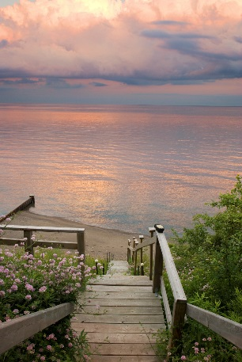

Emily Jane attended local schools and upon graduating from high school she enrolled at Michigan State University where she initially planned to study law, but the desire of her heart was to pursue her love for music so she set education aside for a time to immerse herself in his music. Her thirst for knowledge eventually brought her back to Michigan State where she received her undergraduate degree in psychology. She later moved to Kalamazoo to attend Western Michigan University where she received both her Master’s and Doctorate degrees in psychology.

In the midst of earning her degrees and pursuing a variety of professional endeavors, Emily was also busy raising her four children: Andrea, Alison, Valerie, and Brian, while her husband Andy was a great support in her pursuit of knowledge. She embraced her role as a mother and shared her sense of adventure with her children and she encouraged them to pursue their own dreams, too. Since her educational and career paths left her very busy, he especially cherished the time she spent with her children and the memories they built together were so very precious as well.

While she was continuing her education, she also worked in the local and neighboring school systems. In fact, she was instrumental in establishing and administering many mental health programs for multi-handicapped children throughout various school systems in southwest Michigan. Many of these programs still exist today and are administered through the Kalamazoo Regional Educational Service Agency (KRESA) which is committed to providing a wide variety of quality educational support services and programs across Kalamazoo County and throughout the state. She was also an adjunct faculty member at Western Michigan University where she supervised the practicum placement program. In addition, she additionally ran a private practice.

A myriad of interests and traits made Emily the unique woman that her family, friends, and colleagues knew and loved. Love for music was always a part of her life. She played in several jazz bands and was skilled at the piano, bass, saxophone, guitar, and vocals. She had many additional passions including photography, boating and sailing, fishing, skeet shooting, and flying her planes.